- NewsNova AI
Architecture Document
📌 Overview
NewsNova AI is an AI-powered news platform that simplifies complex news into short, easy-to-understand explanations using AI. It helps students and general users quickly grasp important information without reading long articles.

🏗️ System Architecture
The system follows a simple client-server architecture:
User → Frontend (React) → Backend (Node.js) → AI API → Response → UI

⚙️ Components
1. Frontend (React + Tailwind CSS)
- Displays news articles in card format
- Provides Login/Signup UI
- Includes “Explain” button for AI summaries
- Sends user requests to backend or AI API
- Displays AI-generated explanations

2. News API Integration
- Fetches real-time news headlines from NewsAPI
- Displays title, image, and description
- Updates dynamically on page load

3. Backend (Node.js + Express)
- Handles API requests from frontend
- Sends news content to AI API
- Receives AI response and returns it to frontend
- Ensures secure API key handling

4. AI API (Gemini / OpenAI)
- Processes news headlines
- Generates simplified explanations in Hinglish
- Returns short summaries (2–3 lines)

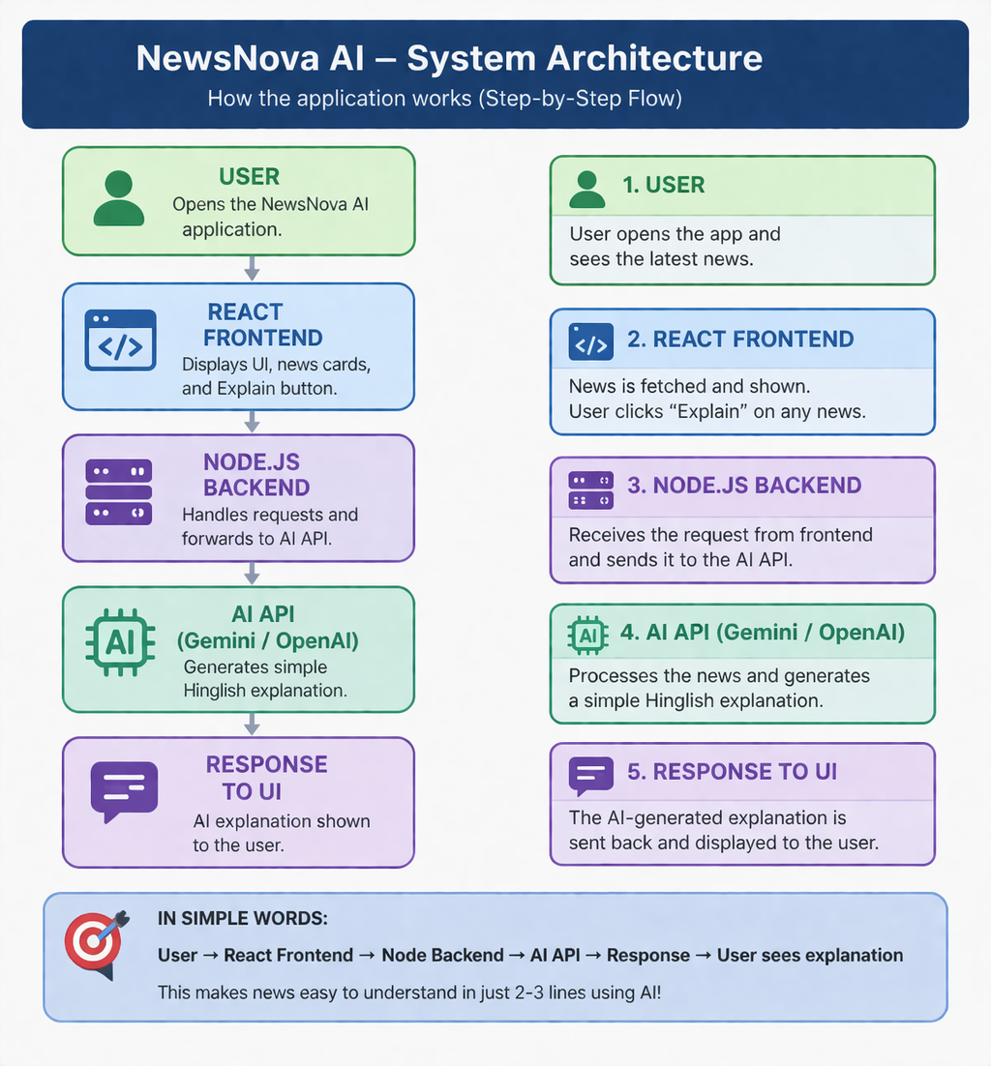
📊 Data Flow
- User opens the application
- Frontend fetches news from News API
- News articles are displayed as cards
- User clicks “Explain” button
- Request sent to backend/AI API
- AI processes the request
- Response sent back to frontend
- Explanation displayed to user
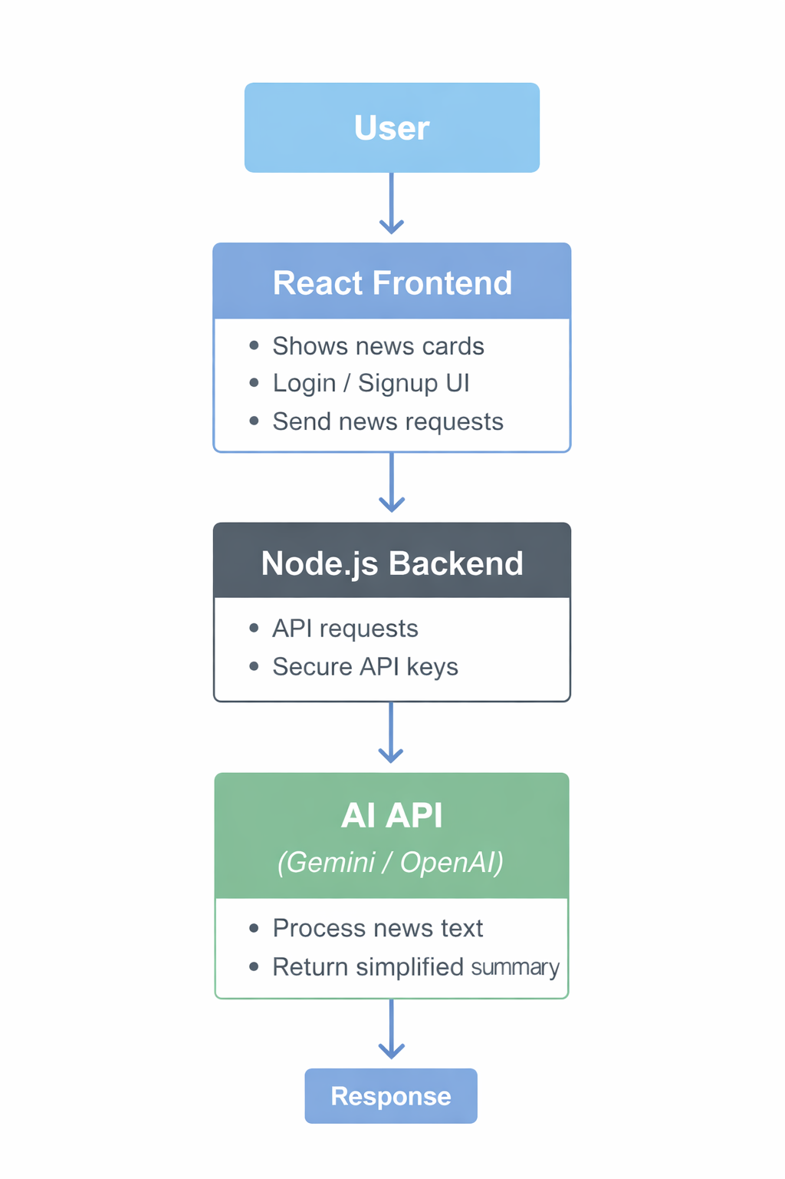

🔐 Security Considerations
- API keys are stored securely
- Backend used to prevent exposing sensitive keys
- CORS enabled for secure communication

📊 Scalability
- Can handle multiple users simultaneously
- AI API can be upgraded for better performance
- Backend can be deployed on cloud (AWS, Vercel, etc.)

🚀 Future Enhancements
- Voice-based AI explanations
- Video summary generation
- Personalized news feed
- Multi-language support

📌 Conclusion
NewsNova AI provides a smart and efficient way to consume news by combining real-time data with AI-powered summarization, making it especially useful for students and busy users.

